**

**CAPSTONE PROJECT REGISTER**

Class: SE Duration time: From 01/2024 to 04/2024

(*) Profession: <Software Engineer> Specialty: <ES>  <IS>  <JS> 

(*) Kinds of person make registers: Lecturer  Students 

# 1. Register information for supervisor (if have)

|  | **Full name** | **Phone** | **E-Mail** | **Title** |
| --- | --- | --- | --- | --- |
| Supervisor 1 | Trương Thị Mỹ Ngọc | 0778081279 | ngocttm4@fe.edu.vn | Ms |

# 2. Register information for students (if have)

| St | **Full name** | **Student code** | **Phone** | **E-mail** | **Role in Group** |
| --- | --- | --- | --- | --- | --- |
| 1 | Đào Minh Trí | SE151125 | 0968680545 | tridmse151125@fpt.edu.vn | Leader – Backend |
| 2 | Nguyễn Thanh Tùng | SE151166 | 0355408098 | tungntse151166@fpt.edu.vn | Backend |
| 3 | Đào Anh Tú | SE151149 | 0937550256 | tudase151149@fpt.edu.vn | Frontend |
| 4 | Nguyễn Công Vũ | SE151184 | 0338010426 | vuncse151184@fpt.edu.vn | Frontend |

# 3. Register content of the Capstone Project

## (*) 3.1. Capstone Project name:

* English: ETailor – Order Management and Tracking System for Tuệ Tailor Shop.
* Vietnamese: Hệ thống quản lý đặt hàng và theo dõi đơn hàng cho nhà may Tuệ.
* Abbreviation: ETailor

## (*) 3.2. Main proposal content (including result and product)

### Theory and practice (document):

###### Students should apply the software development process and UML 2.0 in modeling systems.

* The documents include User Requirements, Software Requirement Specification, Architecture Design, Detail Design, System Implementation and Testing Document, Installation Guide, source code, and deployable software packages.
* Server-side technologies:
* Server: .NET
* Database System: Microsoft SQL Server.
* Client-side technologies:
* Web Client: ReactJS.
* Mobile App: Android Studio.

### Context:

In the traditional landscape of Vietnamese tailor shops, The prevalent issue revolves around the loss of crucial customer information, body attributes, and material details during the garment creation process. That has led to a big change that tailors are gradually considering using technology software to support order management and order tracking.

Tuệ Tailor is a shop in Bình Thạnh district, Ho Chi Minh City. Currently, Tuệ Tailor prefers promoting to customers through the website. The system will help customers to book a service, and to sew new clothes. Then customers can note to change a special part of their clothes. It helps the shop owner to manage those incomes & orders, also they can manage their staff, products, and materials in store (In case it goes out of stock).

In addition to its fundamental features catering to individual tailor shops, the system is designed with scalability in mind, allowing for potential expansion across multiple tailor shops. This scalability stems from the system's architecture and strategic functionalities, enabling its seamless integration into diverse business contexts.

*Photos at Tue Tailor shop*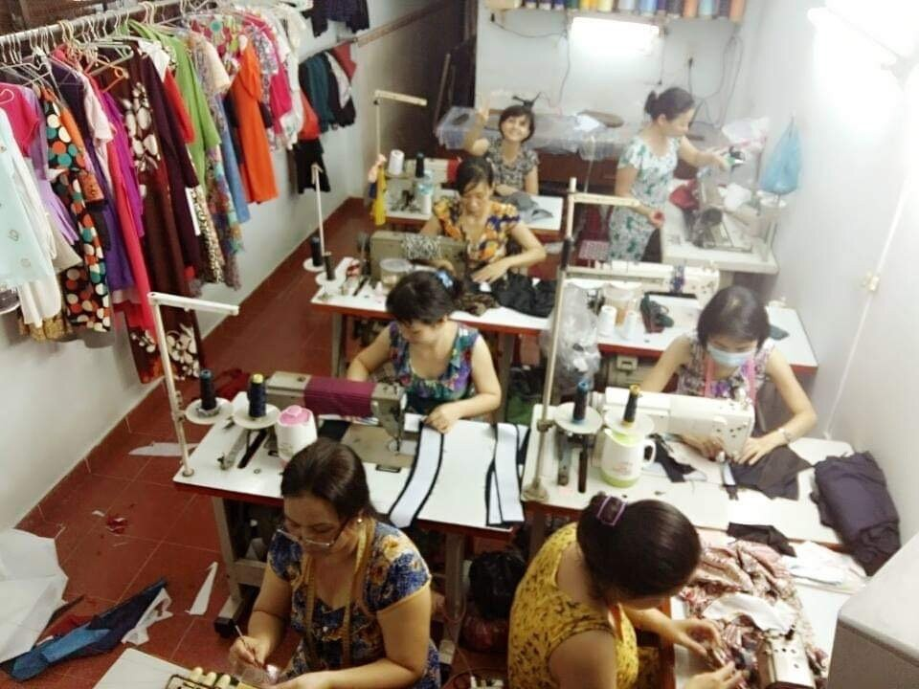

1. Actor & Features:

#### Actors:

#### Admin, Manager, and Customer for website application.

#### Staff for mobile application.

#### Feature lists:

#### Customer:

#### User authentication:

* Users can register and log in as customers to access personalized features.
* Secure login and logout functionality for account management.

###### Profile Management:

* Customers can manage personal details, including name, phone number, and address,...
* Ability to input and update body attributes such as neck size, chest measurements, and other relevant metrics.

###### Product Information:

* Search functionality for customers to explore detailed information on available products.
* Access to a comprehensive catalog with details on color options, fabrics, styles, and more.

###### Shopping Cart Management:

* Customers can conveniently add, remove, and manage items in their shopping carts.
* Seamless shopping cart experience for efficient product selection.

###### Order Management:

* View and track current and past orders through a user-friendly interface.
* Order customization features, allow customers to specify preferences for each item.

###### Financial Transactions:

* Integration with a secure payment gateway for depositing money.
* Streamlined checkout and payment process for a hassle-free transaction experience.

###### Clothing Customization:

* Customers have the ability to customize clothing items, including color, fabrics, styles, and other specifications.

###### Manager:

###### Blog Creation:

* Managers can contribute to the platform by creating and publishing blogs.
* Share insights, fashion tips, or any relevant content to engage with the customer base.

###### Product and Category Management:

* Efficient management of products and their respective categories.
* Adding, updating, and removing products to keep the catalog current and relevant.

###### Material Management:

* Inventory management for materials used in the creation of clothing items.
* Tracking and replenishing materials to avoid stockouts.

###### Staff Management:

* Managing staff profiles, roles, and responsibilities within the system.
* Assigning tasks and tracking performance to optimize workflow.

###### Order Management:

* Oversight of incoming orders with the ability to update order status.
* Managing the materials in the orders provided by the customer.

###### Discount Management.

###### Statistical Analysis:

###### Comprehensive statistics on orders, providing insights into customer preferences.

###### Financial statistics, tracking income, and identifying revenue trends.

###### Admin:

###### Manage users & all accounts.

###### Manage system configurations

###### Manage unit of measurement

###### Staff:

###### Check orders received from the system, then sew clothes as notes in orders.

###### Create new profiles and input body attributes for customers.

| **Supervisor (If have)**  *(Sign and full name)* | HCM, date 12 Dec 2023  **On behalf of Registers**  *(Sign and full name)* |
| --- | --- |